Encapsulating Sum (linear algebra)

Def

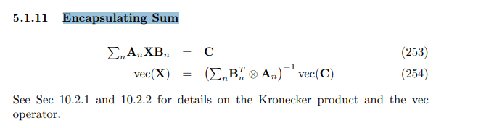

See also

For simple intro about Encapsulating Sum of matrix, see Section 5.1.11 in the cookbook.

For more details about Kronecker product, see Section 10.1 and 10.2 in the cookbook.

Ref

[Wayback Machine (archive.org)](https://web.archive.org/web/20090521075124/http://www2.imm.dtu.dk/pubdb/views/edoc_download.php/3274/pdf/imm3274.pdf)